**MUSIC**

**GENRE**

**CLASSIFICATION**

**WITH**

**DEEP LEARNING**

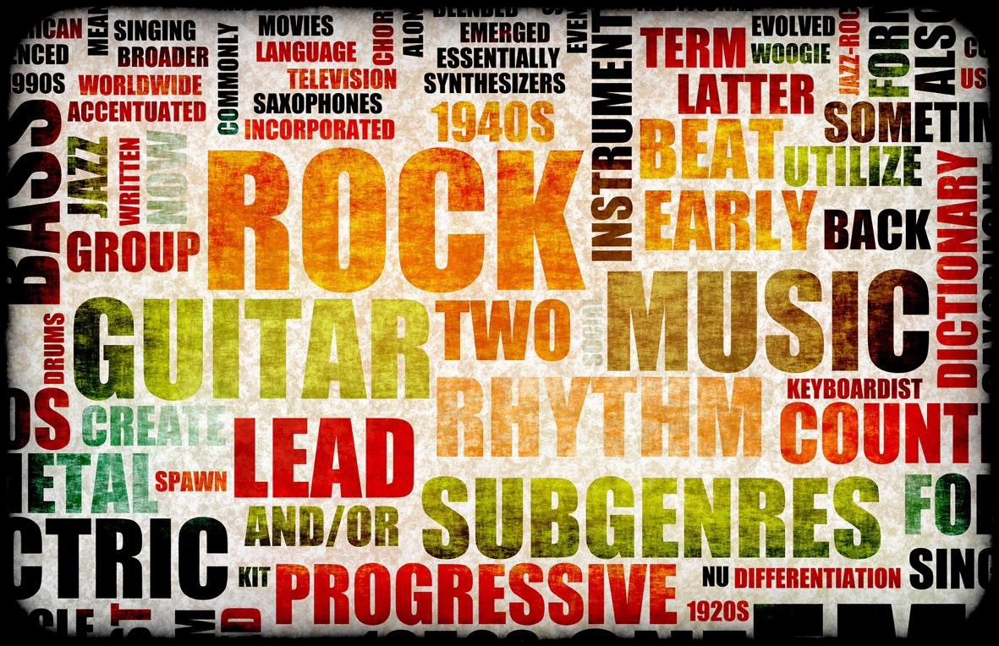

**TEAM 20 -> KAUSHIK PATIL (001056490)**

1. **Introduction**
   1. **Background**

*Music is like a mirror, and it tells people a lot about who you are and what you care about, whether you like it or not. We love to say, “you are what you stream” - Spotify*

A Music Genre is a conventional category that identifies some pieces of music. Music can be divided into genres in many different ways. The artistic nature of music means that the classifications are subjective, and some genres may overlap with one another.

Some of the popular music genres are hip-hop, rock, country etc. It is very difficult to put a music into one category of music as it may have parts which belong to another category (genres) of music. There are differences between genres of music like hip-hop and heavy metal. Heavy metal music generally uses more bass and high-pitched sounds of musical instruments while hip-hop mainly focuses on the vocals. Grouping the music into one genre is important because each individual is different as has a different taste in music. By grouping, we can allow users to listen to the music which they like.

* 1. **Motivation**

As a lover of both music and data, the idea of combining the two sounded enticing. Innovative companies such as Spotify and Shazam have been able to leverage music data in a clever way to provide amazing services to users! I wanted to try my hand at working with audio data and try to build a model that could automatically classify a song by its genre.

An automatic genre classification algorithm could greatly increase efficiency for music databases. It could also help music recommender systems and playlist generators that companies like Spotify and Pandora use. It’s also a really fun problem to play around with if you love music and data!

* 1. **Goal**

So, considering every information, our goal is to develop a classifier for music genre using deep learning techniques with best accuracy we can attained from trained model and dataset.

1. **Methodology**

**2.1 Hardware Specifications**

**Cluster:** Discovery High-Performance Computing Cluster

Reservation: csye7105-gpu

Reservation memory: 100 GB

Time reserved: 08 hrs.

**GPU**

Model: Nvidia V100-SXM2

GPU count: 1,2 and 4

GPU Memory: 32.4805 GB / GPU

Clock: 1.290Ghz with max boost of 1.530GHz

**CPU**

Model: Intel(R) Xeon(R) Gold 6132 CPU @ 2.60GHz

Sockets: 2

Cores/socket: 14

Threads/core: 1

CPUs: 28

**2.2 Architecture of the Model**

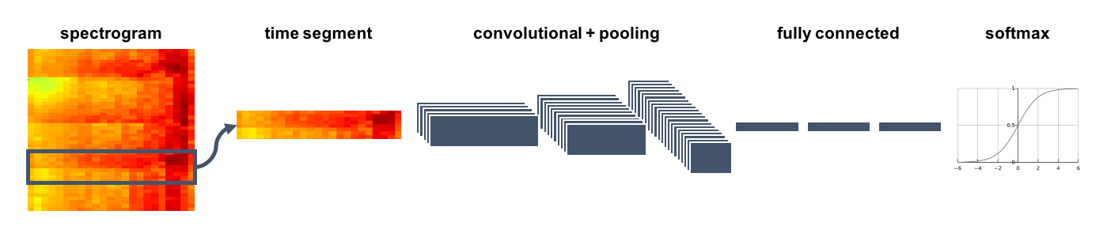

genreNet (

self.conv1 = Conv2d(in_channels=1, out_channels=64, kernel_size=3, stride=1, padding=1) self.bn1 = BatchNorm2d(64)

self.pool1 = MaxPool2d(kernel_size=2)

self.conv2 = Conv2d(in_channels=64, out_channels=128, kernel_size=3, stride=1, padding=1)

self.bn2 = BatchNorm2d(128)

self.pool2 = MaxPool2d(kernel_size=2)

self.conv3 = Conv2d(in_channels=128, out_channels=256, kernel_size=3, stride=1, padding=1)

self.bn3 = BatchNorm2d(256)

self.pool3 = MaxPool2d(kernel_size=4)

self.conv4 = Conv2d(in_channels=256, out_channels=512, kernel_size=3, stride=1, padding=1)

self.bn4 = BatchNorm2d(512)

self.pool4 = MaxPool2d(kernel_size=4)

self.fc1 = Linear(in_features=2048, out_features=1024)

self.drop1 = Dropout(0.5)

self.fc2 = Linear(in_features=1024, out_features=256)

self.drop2 = Dropout(0.5)

self.fc3 = Linear(in_features=256, out_features=10))

x = F.relu(self.fc1(x))

x = self.drop1(x)

x = F.relu(self.fc2(x))

x = self.drop2(x)

x = F.log_softmax(self.fc3(x))

**2.3 Code Running Steps**

module load anaconda3/3.7

source activate py2020

cd CSYE7105_FinalProject/src/

python3 config.py

python3 data.py

python3 set.py

python3 model.py

python3 train.py

1. **Dataset**

The dataset used is GTZAN dataset. The dataset can be downloaded directly from this link-

[**https://www.kaggle.com/andradaolteanu/gtzan-dataset-music-genre-classification**](https://www.kaggle.com/andradaolteanu/gtzan-dataset-music-genre-classification)

The dataset contains 10 classes/genres of music, these are:

**• Metal.**

**• Disco.**

**• Classical.**

**• Hip-hop.**

**• Jazz.**

**• Country.**

**• Pop.**

**• Blues.**

**• Reggae.**

**• Rock.**

**genres original -** A collection of 10 genres with 100 audio files each, all having a length of 30 seconds (the famous GTZAN dataset, the MNIST of sounds)

**images original -** A visual representation for each audio file. One way to classify data is through neural networks. Because NNs (like CNN, what we will be using today) usually take in some sort of image representation, the audio files were converted to Mel Spectrograms to make this possible.

**CSV files -** Containing features of the audio files. One file has for each song (30 seconds long) a mean and variance computed over multiple features that can be extracted from an audio file. The other file has the same structure, but the songs were split before into 3 seconds audio files (this way increasing 10 times the amount of data we fuel into our classification models).

1. **Results and Analysis**

Before analysis of the dataset, we should understand and make plan for successful execution of processes and tasks. The foremost thing of the analysis is to do data pre-processing to understand the information in the dataset. We will achieve this using Jupyter Notebook.

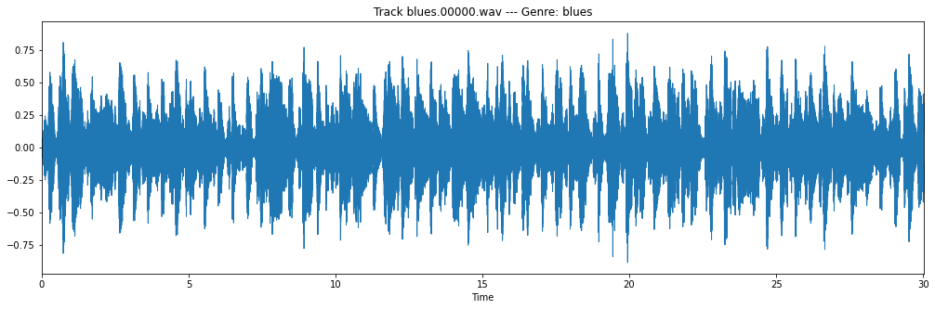

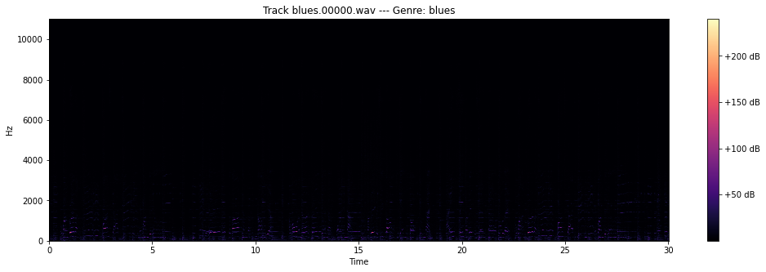

These are the two types of graphs wave plots and color bar for specific genre extracted from data using librosa.

Mel-Spectrogram is the function that I will extract from the audio files and then will store all the spectrograms in the npz format. We will Generate the log Mel spectrogram using an audio time series. Optionally this function will also plot the log Mel spectrogram.

We will also generate the log Mel spectrograms for all the tracks in the given pandas data frame.

Pandas dataframe contains the tracks to convert to log Mel spectrograms for all genres and the Distribution of genres is fairly even, so we don't have to worry about our models being biased towards one genre.

Spectrograms are very important to know and distinguish the categories in the dataset and can be used for further analysis.

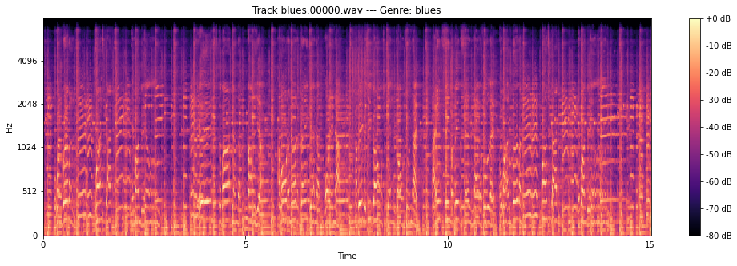

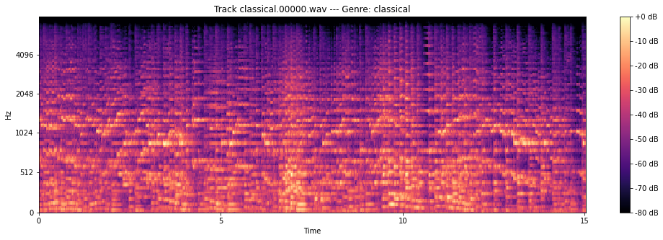

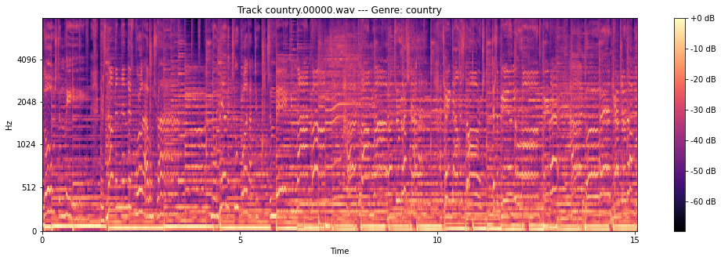

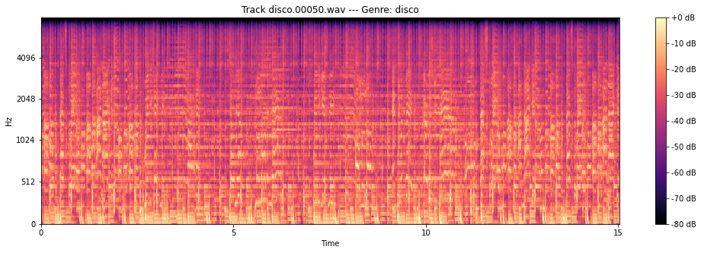

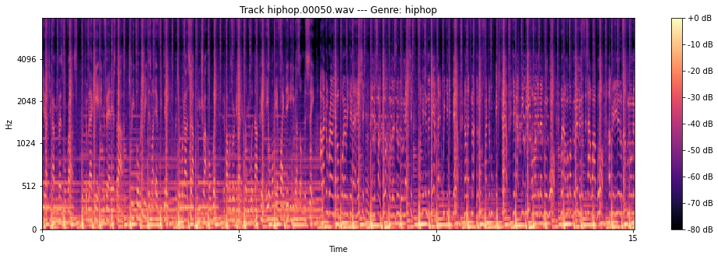

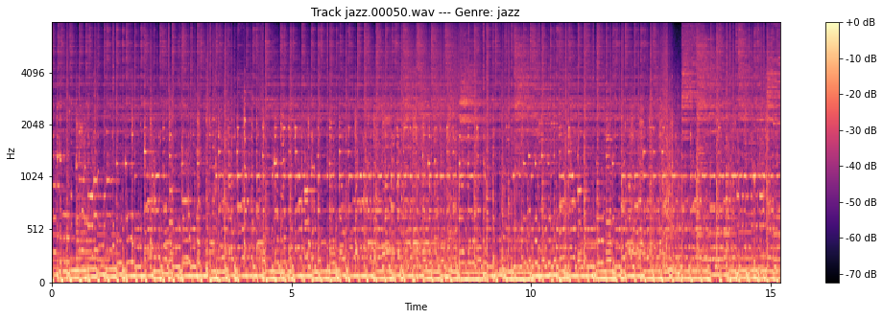

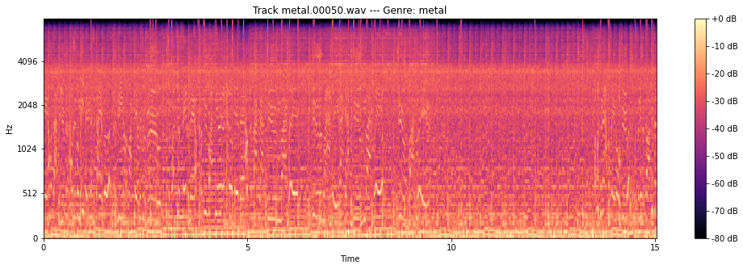

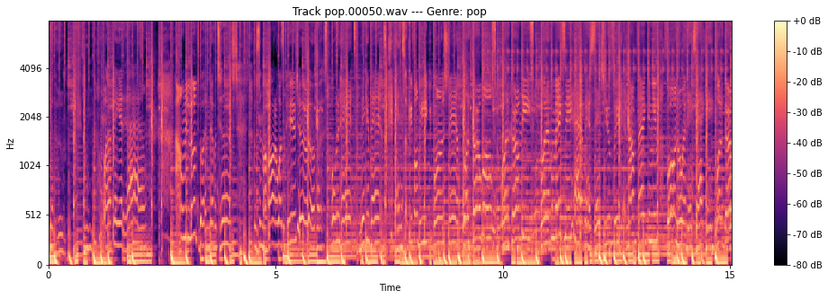

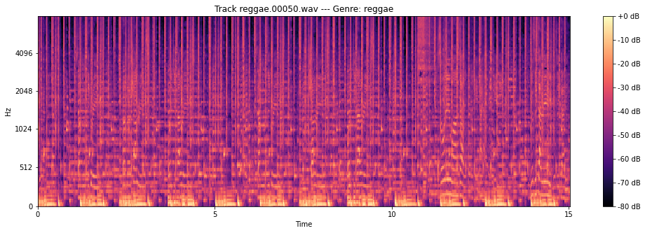

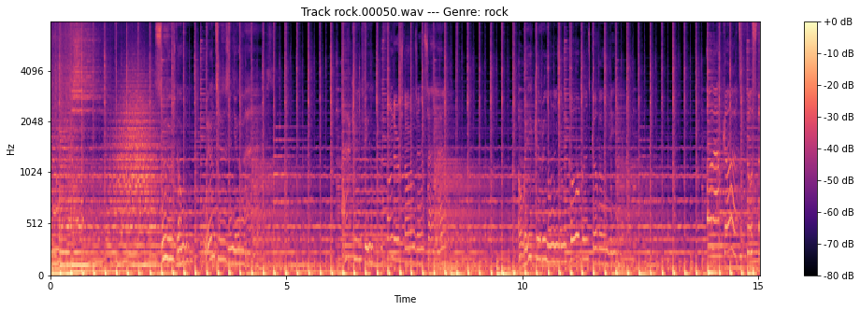

To gain some intuition into the relationships between the spectrograms we can use PCA to project them into two dimensions.

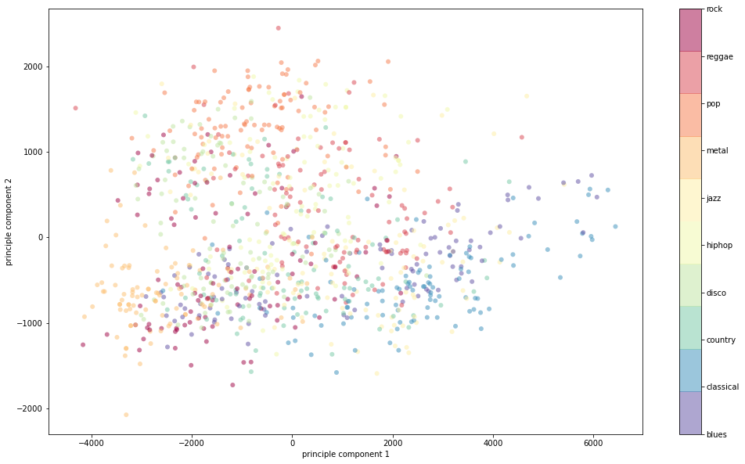

Principal component analysis (PCA) is a technique for reducing the dimensionality of such datasets, increasing interpretability but at the same time minimizing information loss. It does so by creating new uncorrelated variables that successively maximize variance.

In other words, PCA helps you interpret your data, but it will not always find the important patterns. Principal component analysis (PCA) simplifies the complexity in high-dimensional data while retaining trends and patterns. It does this by transforming the data into fewer dimensions, which act as summaries of features.

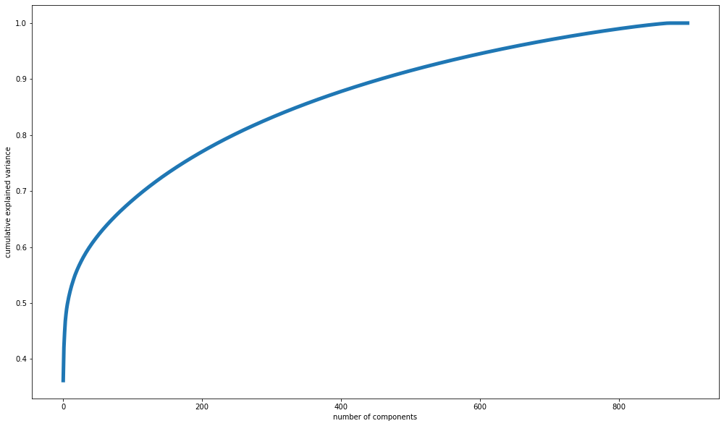

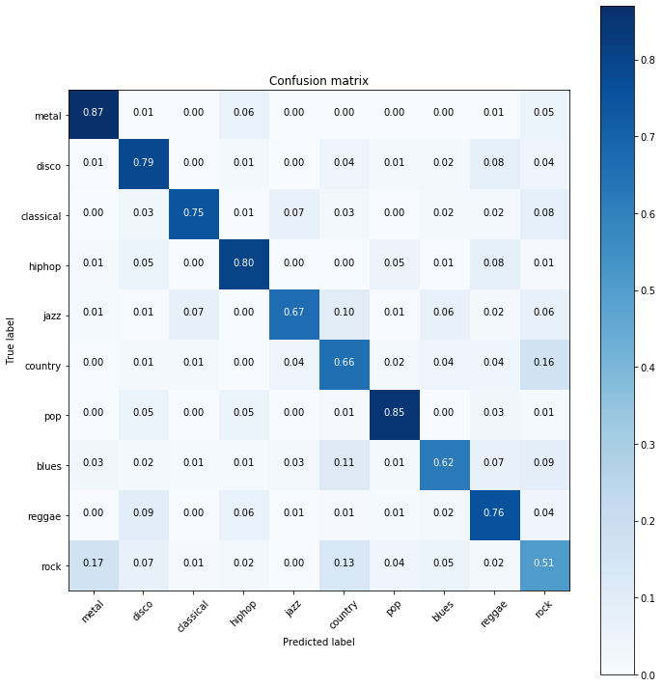

This curve quantifies how much of the total, 81920-dimensional variance is contained within the first N components. For example, we see that with the first 190 principal components contain approximately 75% of the variance, while you need around 850 components to describe close to 100% of the variance. We can also see that after 850ish principal components the remaining components explain none of the variance. This tells us we should definitely be performing PCA before throwing the data into our models. This is also important because while performing PCA we are effectively keeping the parts of the songs that make them stand out and removing the similar parts, this will help us better differentiate the genres.

After understanding and preprocessing the dataset, we can start analysis with various experiments on the dataset.

Following are the experiments performed on various batch sizes. For every case, the

following are constant:

1. x_train shape: (7000, 1, 128, 128)

y_train shape: (7000,)

x_valid shape: (2000, 1, 128, 128)

y_valid shape: (2000,)

x_test shape : (1000, 1, 128, 128)

y_test shape : (1000,)

1. Number of epochs: 2500 (since changing them will cause run time variations). So, fixing epochs is essential for generalizing our results and observations.
2. Optimizer: RMSProp (based on empirical results)
3. Criterion: CrossEntropyLoss which combines nn.LogSoftmax() and nn.NLLLoss() in one single class.
4. Activation: ReLU (Rectified Linear Units) are used since they lead to faster computation reducing run time by ~25%.
5. Dropout factor is 50%. This is again kept constant for generalization and as we know the dropout helps in regularization and prevents overfitting our models.

Our main objectives are:

1. What is the time consumed by GPUs on 64, 128 and 256 batch size of images?
2. What is the memory consumption of the GPUs with specific batch sizes?
3. Reasonable tradeoff in performance time and batch size by finding an optimal number of GPU and data batches.

GENRES = [ 'blues',

'classical',

'country',

'disco',

'hiphop',

'jazz',

'metal',

'pop',

'reggae',

'rock' ]

**Experiment 1: GPU = 1**

**GPU:** v100-sxm2

**Reservation:** csye7105-gpu

**Epoch:** 2500

**Batch Size: 64**

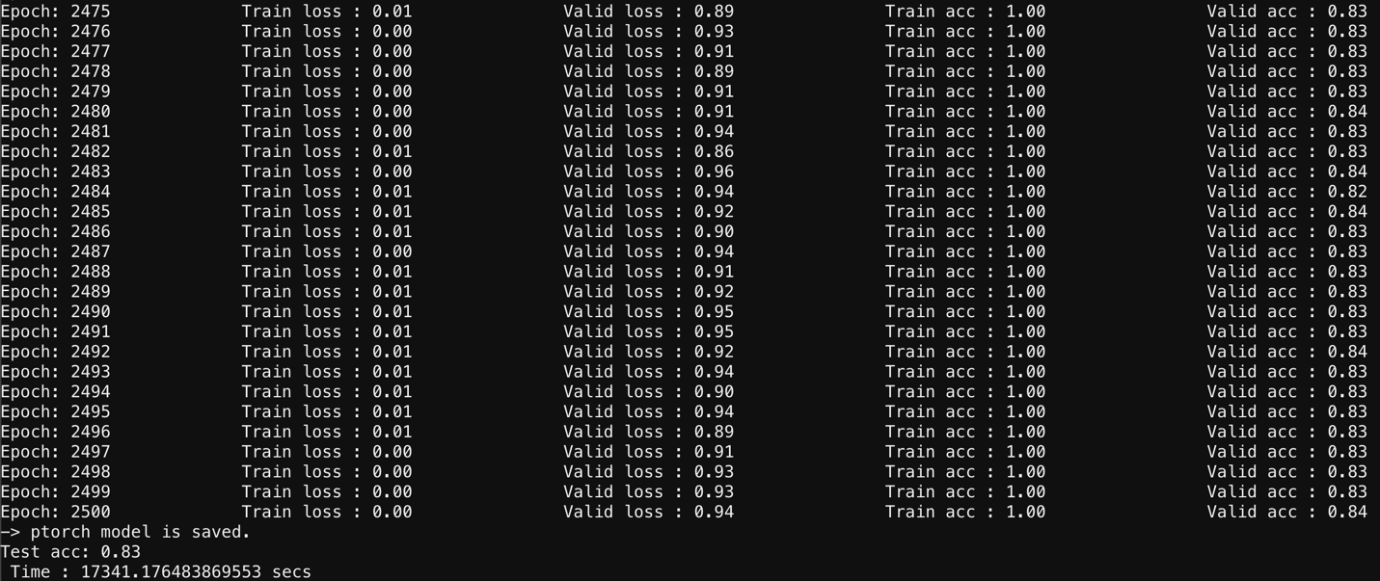

**GPU:** v100-sxm2

**Reservation:** csye7105-gpu

**Epoch:** 2500

**Batch Size: 128**

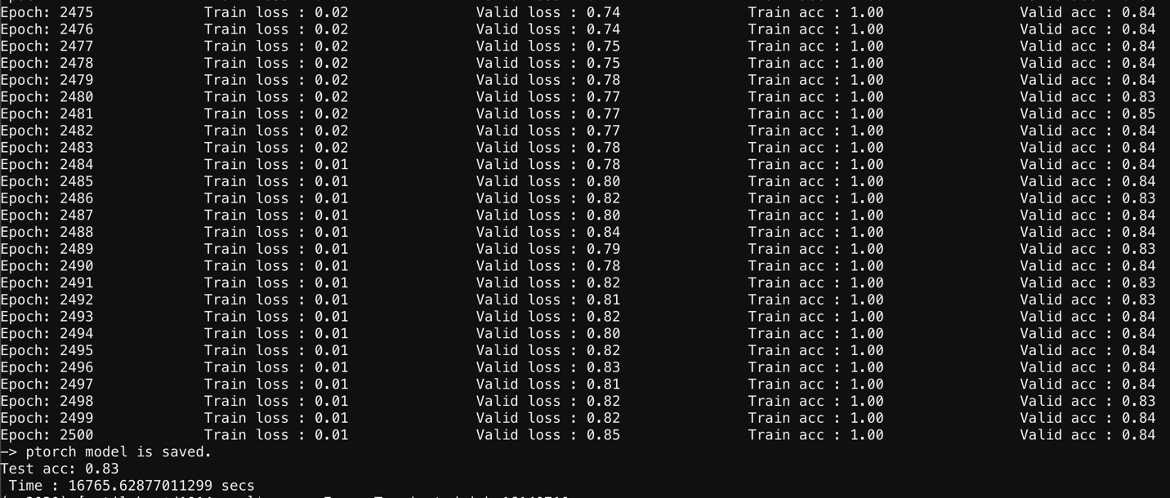

**GPU:** v100-sxm2

**Reservation:** csye7105-gpu

**Epoch:** 2500

**Batch Size: 256**

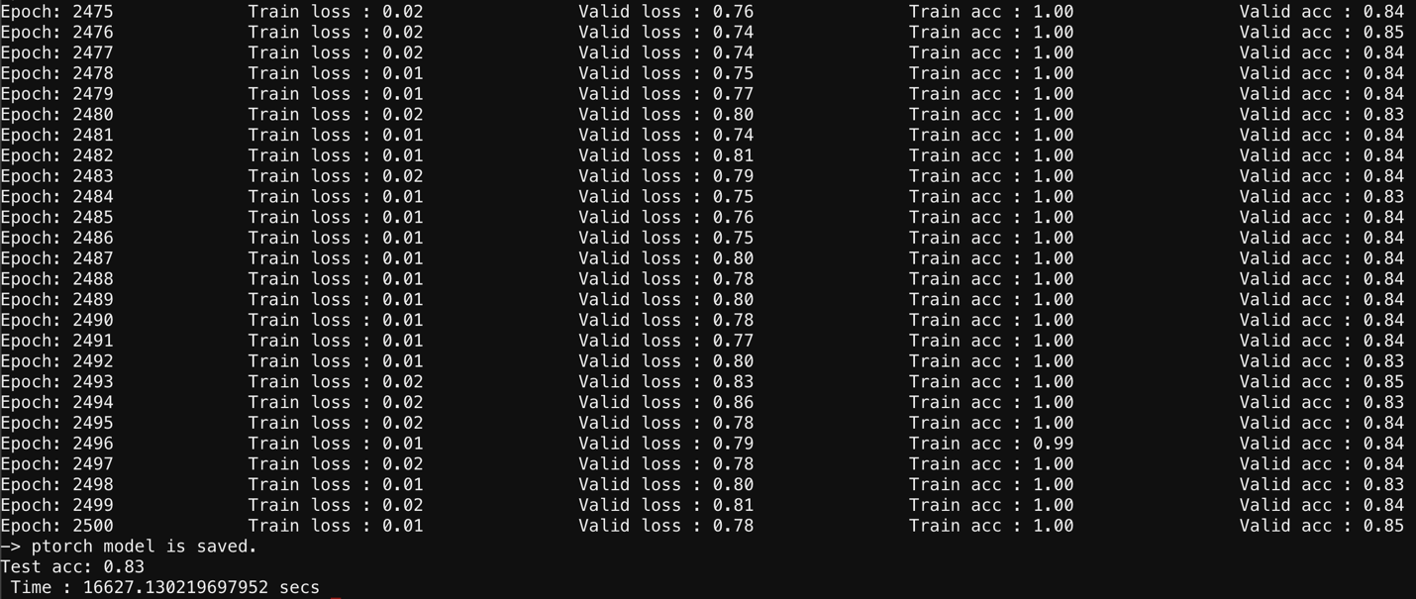

After the experiment 1, we get accuracy of 0.83, and as the batch size is increasing, the time consumption is becoming less as this is single GPU. For other cases, we will run the model on 2 and 4 GPUs to see whether the batch size affects the accuracy and performance of the model.

|  |  |  |  |  |  |
| --- | --- | --- | --- | --- | --- |
| **Experiment 1**  **(1 GPU)** | **Execution Time** | **Data Parallel** | **Train Accuracy** | **Valid Accuracy** | **Test Accuracy** |
| Batch Size 64 | 17341.13 secs | No | 99.94 | 83.42 | 83.45 |
| Batch Size 128 | 16765.63 secs | No | 99.87 | 83.34 | 83.41 |
| Batch Size 256 | 16627.13 secs | No | 99.66 | 83.27 | 83.38 |

**Experiment *2*: GPU = 2**

**GPU:** v100-sxm2

**Reservation:** csye7105-gpu

**Epoch:** 2500

**Batch Size: 64**

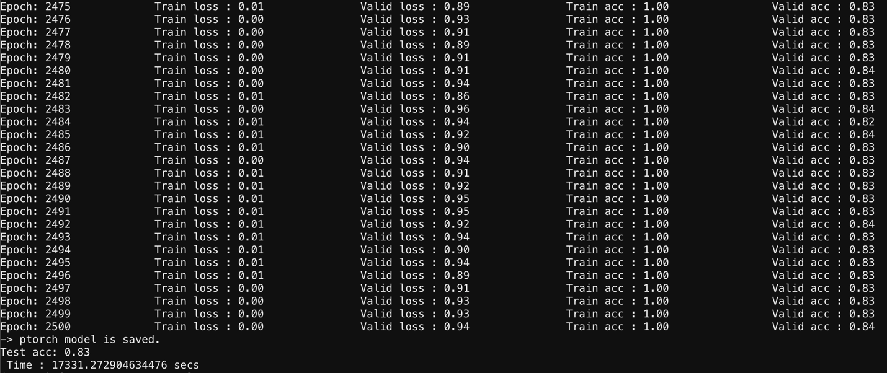

**GPU:** v100-sxm2

**Reservation:** csye7105-gpu

**Epoch:** 2500

**Batch Size: 128**

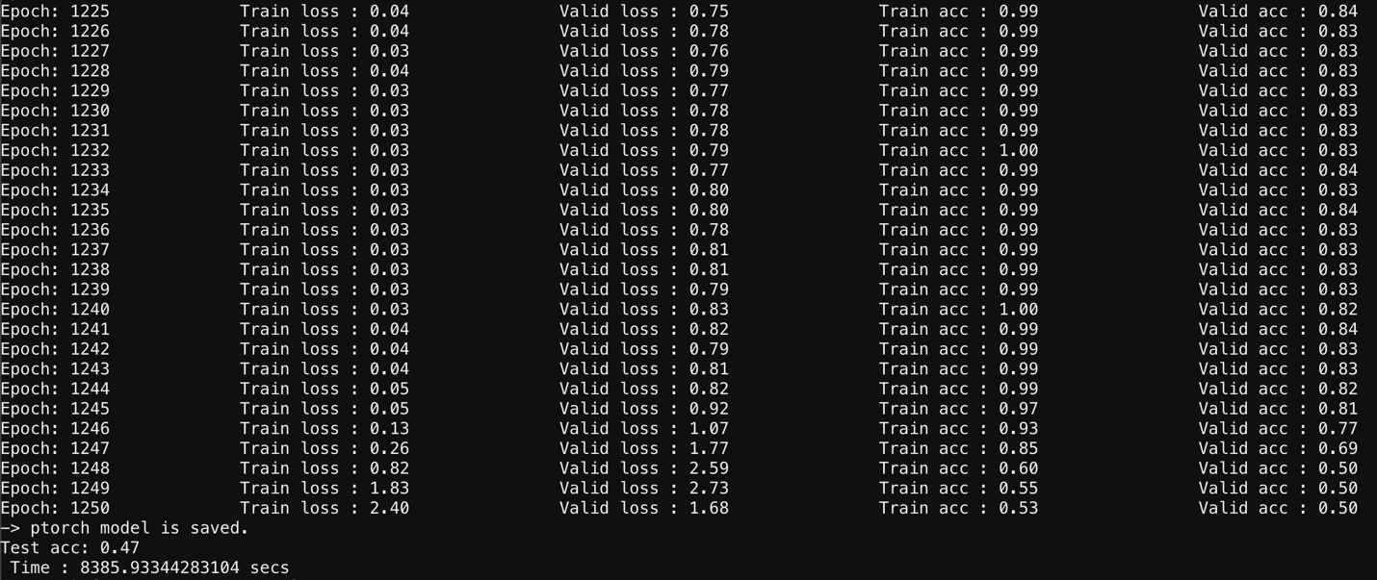

**GPU:** v100-sxm2

**Reservation:** csye7105-gpu

**Epoch:** 2500

**Batch Size: 256**



As we can notice that for batch size 128, the time consumption is less irrespective of increase in batch size before and after it in comparison. This is the optimal model compared to remaining 8 models as it has less execution time with high accuracy. So it’s not always batch size which enhances the performance of the train ed model.

|  |  |  |  |  |  |
| --- | --- | --- | --- | --- | --- |
| **Experiment 2**  **(2 GPU)** | **Execution Time** | **Data Parallel** | **Train Accuracy** | **Valid Accuracy** | **Test Accuracy** |
| Batch Size 64 | 17331.27 secs | Yes | 99.89 | 83.45 | 83.49 |
| Batch Size 128 | 16771.86 secs | Yes | 99.94 | 83.47 | 83.51 |
| Batch Size 256 | 17341.10 secs | Yes | 99.82 | 83.39 | 83.43 |

**Experiment 3: GPU = 4**

**GPU:** v100-sxm2

**Reservation:** csye7105-gpu

**Epoch:** 2500

**Batch Size: 64**

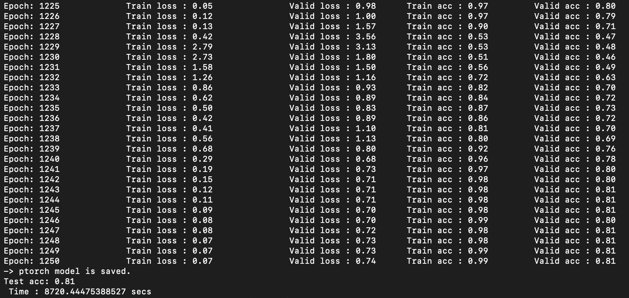

**GPU:** v100-sxm2

**Reservation:** csye7105-gpu

**Epoch:** 2500

**Batch Size: 128**

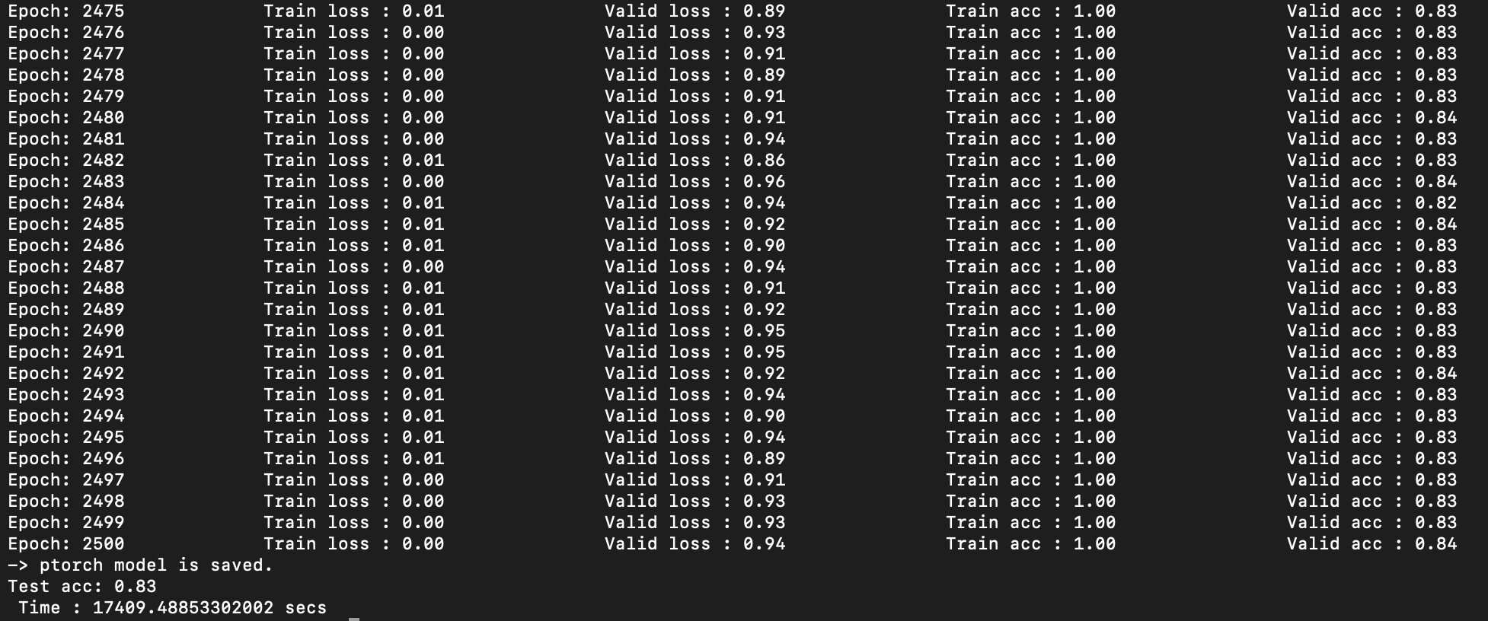

**GPU:** v100-sxm2

**Reservation:** csye7105-gpu

**Epoch:** 2500

**Batch Size: 256**



|  |  |  |  |  |  |
| --- | --- | --- | --- | --- | --- |
| **Experiment 3**  **(4 GPU)** | **Execution Time** | **Data Parallel** | **Train Accuracy** | **Valid Accuracy** | **Test Accuracy** |
| Batch Size 64 | 17440.88 secs | Yes | 99.88 | 83.41 | 83.46 |
| Batch Size 128 | 17409.48 secs | Yes | 99.85 | 83.37 | 83.44 |
| Batch Size 256 | 16765.62 secs | Yes | 99.90 | 83.42 | 83.48 |

Going through the analysis, here we find higher the batch size, greater the performance and lower is the execution time. It contradicts the experiment 2, but it is advisable to use data parallel for high batches which can lead to significant degradation of quality of model because of minimizers of training.

Talking about running on CPU, it took a lot of time to run a single epoch compared to high performance GPU computing. it took **1370.0338 secs** for a single run. That’s ~**24 mins** for a single epoch.

1. **Cross Validation**

We tested our model after training, and we got amazing results.

We tested our model on three genres from the dataset and with the help of 83% accuracy, the prediction was right.

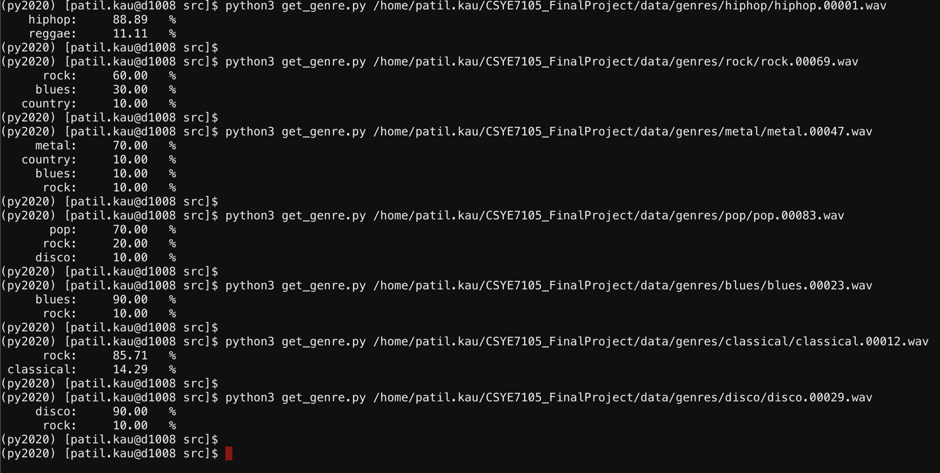

As we can see from the screenshot of the terminal, the trained model is easily predicting the genres for the music and classifying it. It also extracts mix features of two genres which is closely related. After analysis, we came to know that hiphop, rock and disco were having high prediction accuracy.

For challenging the trained model based on this dataset, I thought of downloading a music song of specific genre to see if it can predict the genre correctly or not.

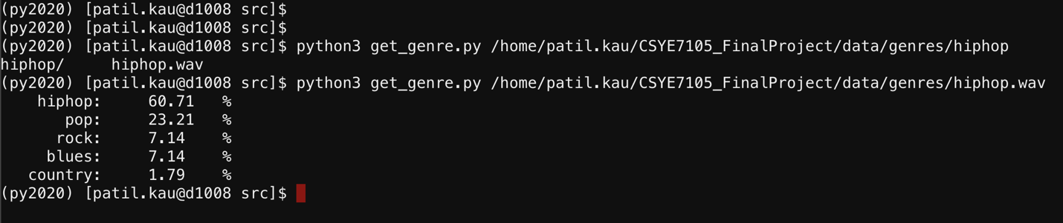

1. **Conclusion**
2. It doesn't actually boost performance by using more GPUs. There are cases where we get decent results for a particular batch size.
3. It is not necessary to increase accuracy or model approximation capability by using larger batches. In fact, in some case, the greater the batch size, the lower the generalization capability.
4. A strong tradeoff occurs between the number of batches and the number of GPUs that can be used in parallel. As can be seen from the above evaluation, given the amount of memory being consumed on each GPU, memory use was not efficient and thus we would like to see better memory allocation as well as time consumption.
5. We can improve the test accuracy using maximum of GPU memory and if batch is not perfect, we must use Data Parallelism.

**7. References**

1. How to apply machine learning and deep learning methods to audio analysis

[https://towardsdatascience.com/how-to-apply-machine-learning-and-deep-learning-methods-to audio-analysis-615e286fcbbc](https://towardsdatascience.com/how-to-apply-machine-learning-and-deep-learning-methods-to%20audio-analysis-615e286fcbbc)

1. Exploring different approaches for music genre classification

<https://www.sciencedirect.com/science/article/pii/S1110866512000151>

1. Music Genre Classification and Recommendation by Using Machine Learning Techniques

<https://ieeexplore.ieee.org/document/8554016>

1. Music Genre Classification with Paralleling Recurrent Convolutional Neural Network

<https://arxiv.org/abs/1712.08370>

1. Oramas S, Barbieri F, Nieto O, Serra X. Multimodal deep learning for music genre classification. Transactions of the International Society for Music Information Retrieval. 2018;1(1):4-21. DOI: 10.5334/tismir.10